**Group:** SE-2116

**Names:** Kusainov Aslan, Yesbossyn Aiym, Komekbayev Zeyin, Gabdullin Olzhas, Batyr Aldiyar

**Topic: Buying a Dog (Singleton)**

**Github: https://github.com/sat0urn/dogselector_javafx**

**Project Description:**

The client, according to the survey, chooses a dog for himself according to the parameters. Next, the program invites him to buy it, and gives a choice

Do you want to buy this dog?

Yes or no

If yes, then the program asks for the client's data, and then Signs the user by

entered data + dog breed.

Then the client waits for the required date, and he is given the opportunity to check whether the dogs are ready for collection.

Notification provided that the Current Date is the One needed to prepare the dog for transport to the client's home. It will be in the form of a choice at the beginning

Whether you want to check the Pickup Date OR continue the cycle.

After all returning DB within all data about dog included in person who bought it.

Choosing the most popular dog among dog breeds who are chosen the most.

Job done:

1. Created HTML for better UX/UI
2. Singleton pattern
3. Photos of dogs in selection

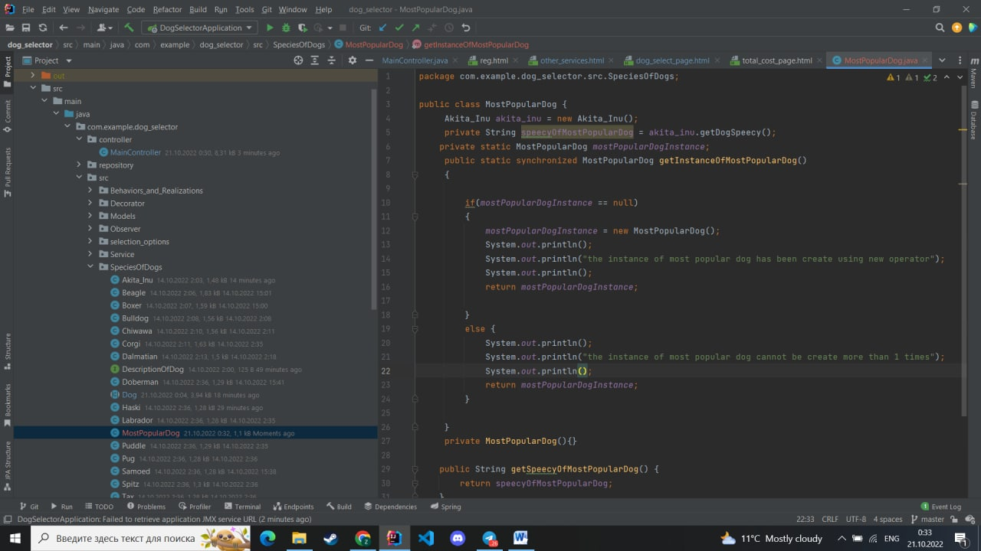

Picture 1. Singleton

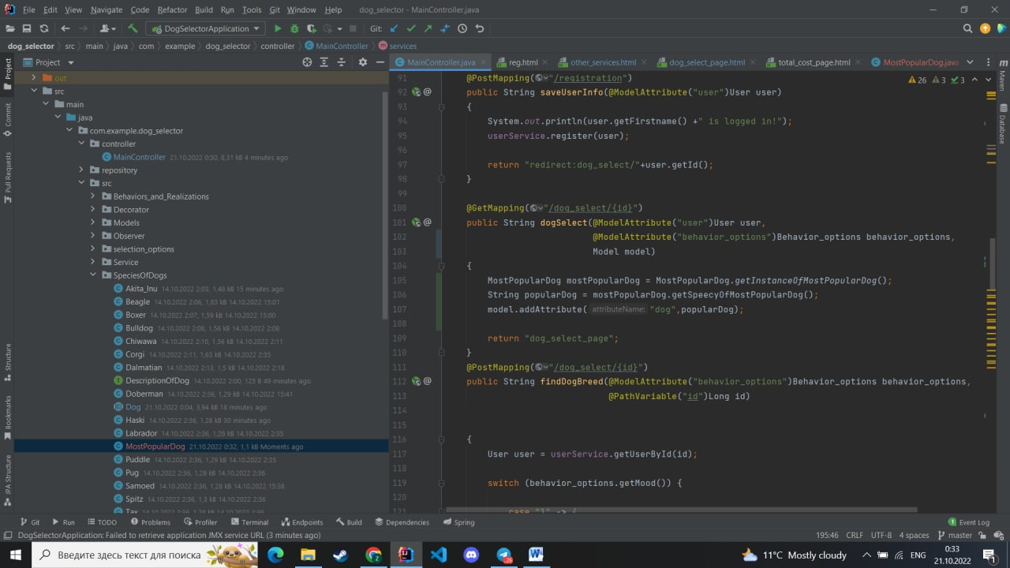

Picture 2. MostPopularDog

Picture 3. MainController

Picture 4. Terminal results

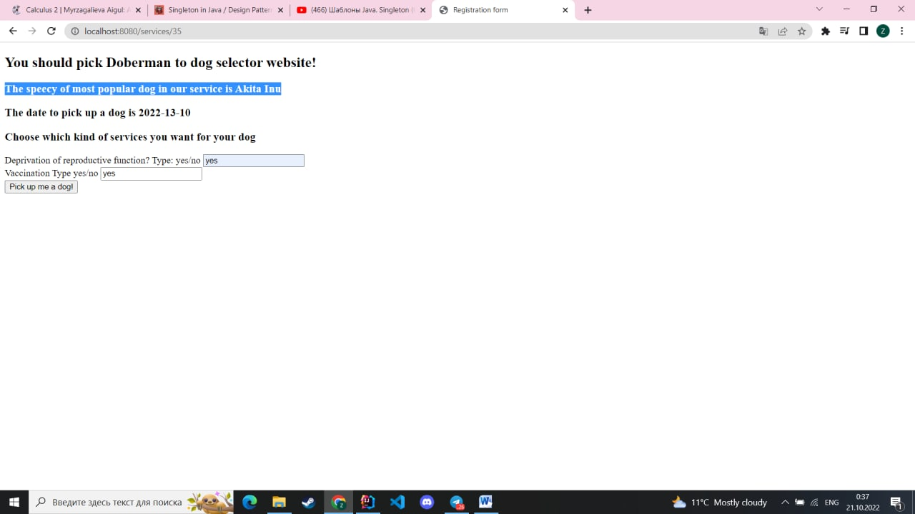

Picture 5. Localhost results.

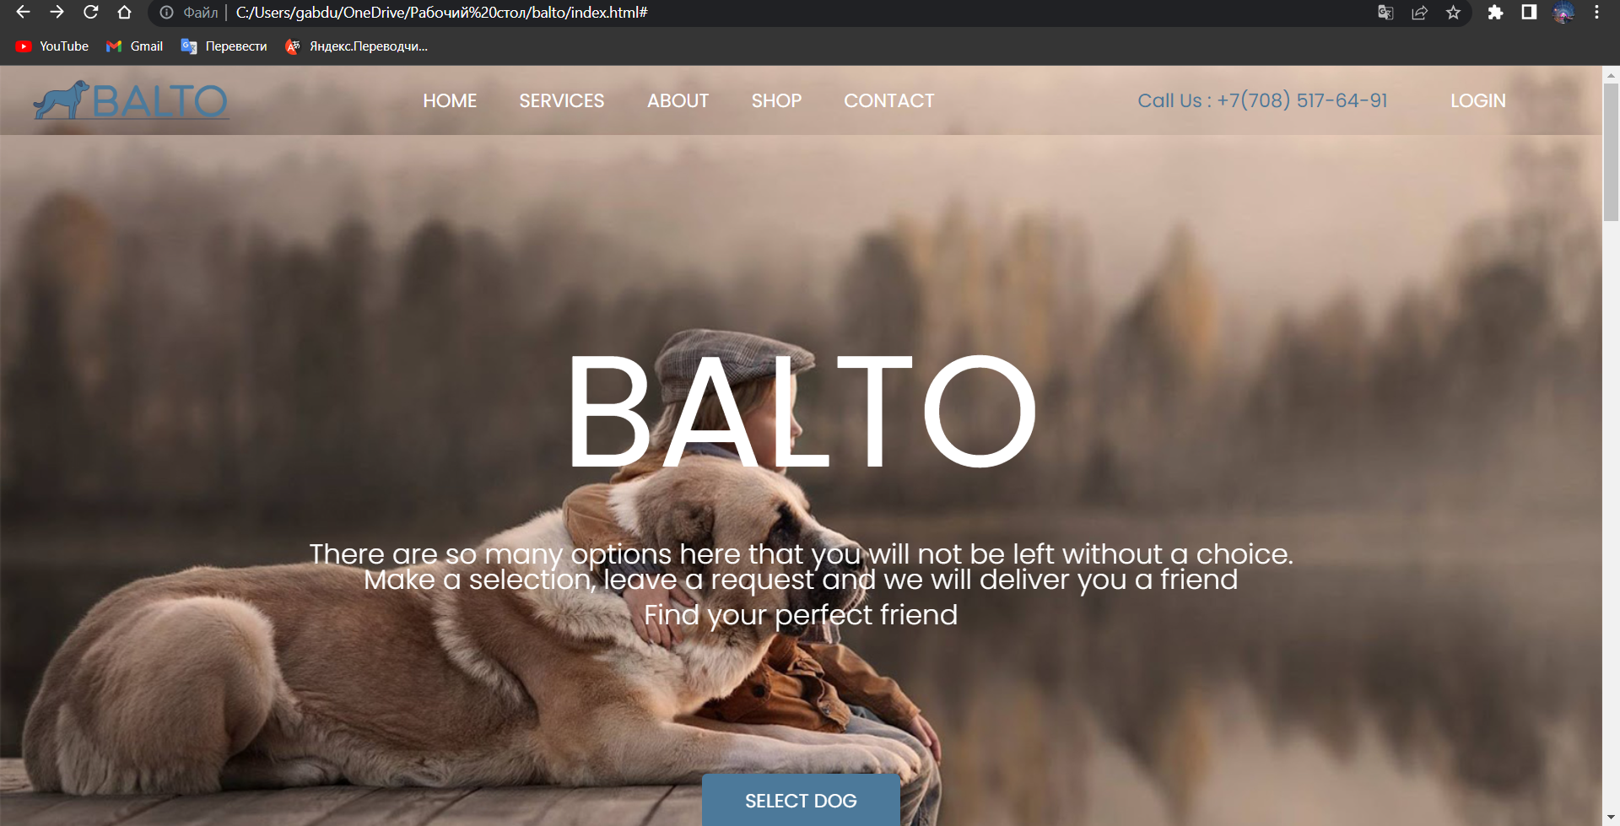

Picture 6. HTML page

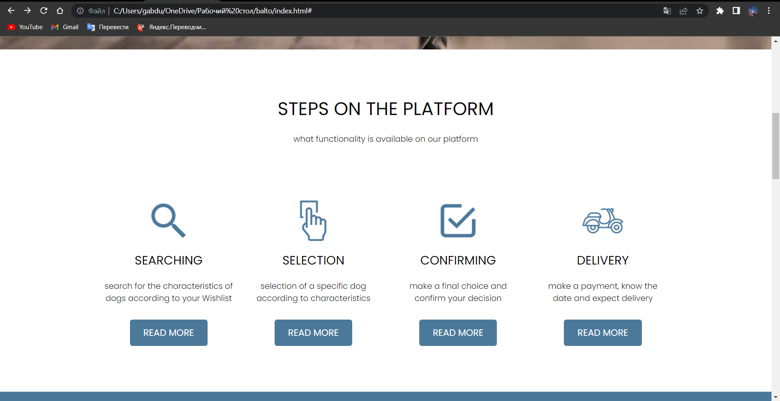

Picture 7.

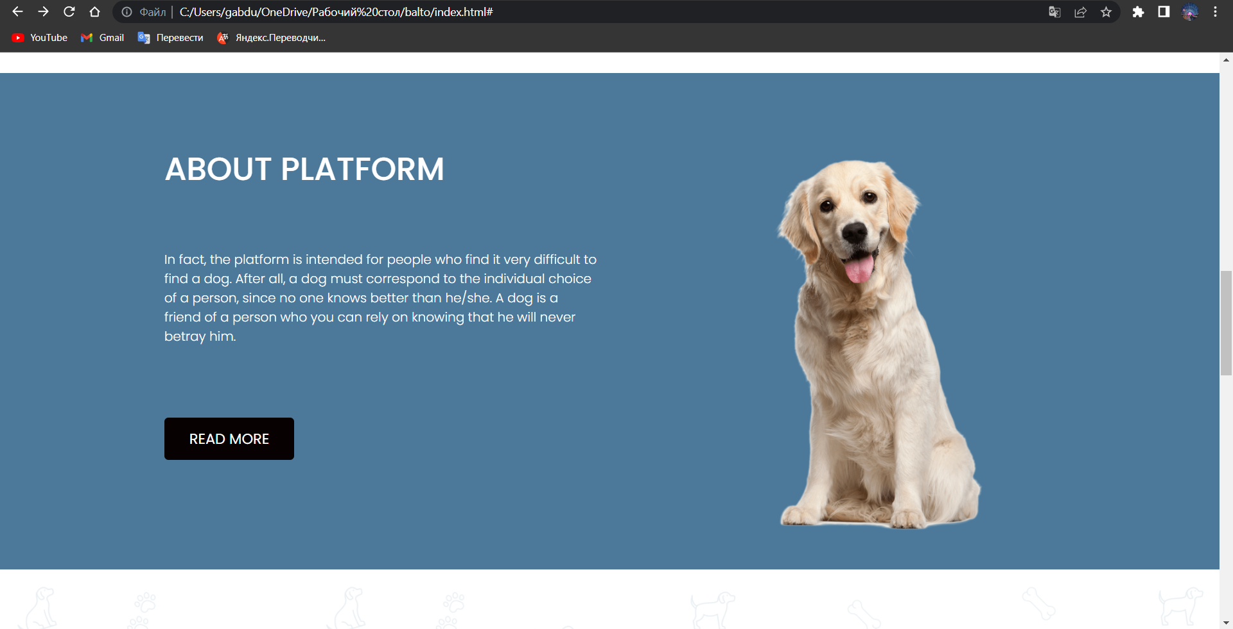

Picture 8.

Picture 9.

Picture 10.

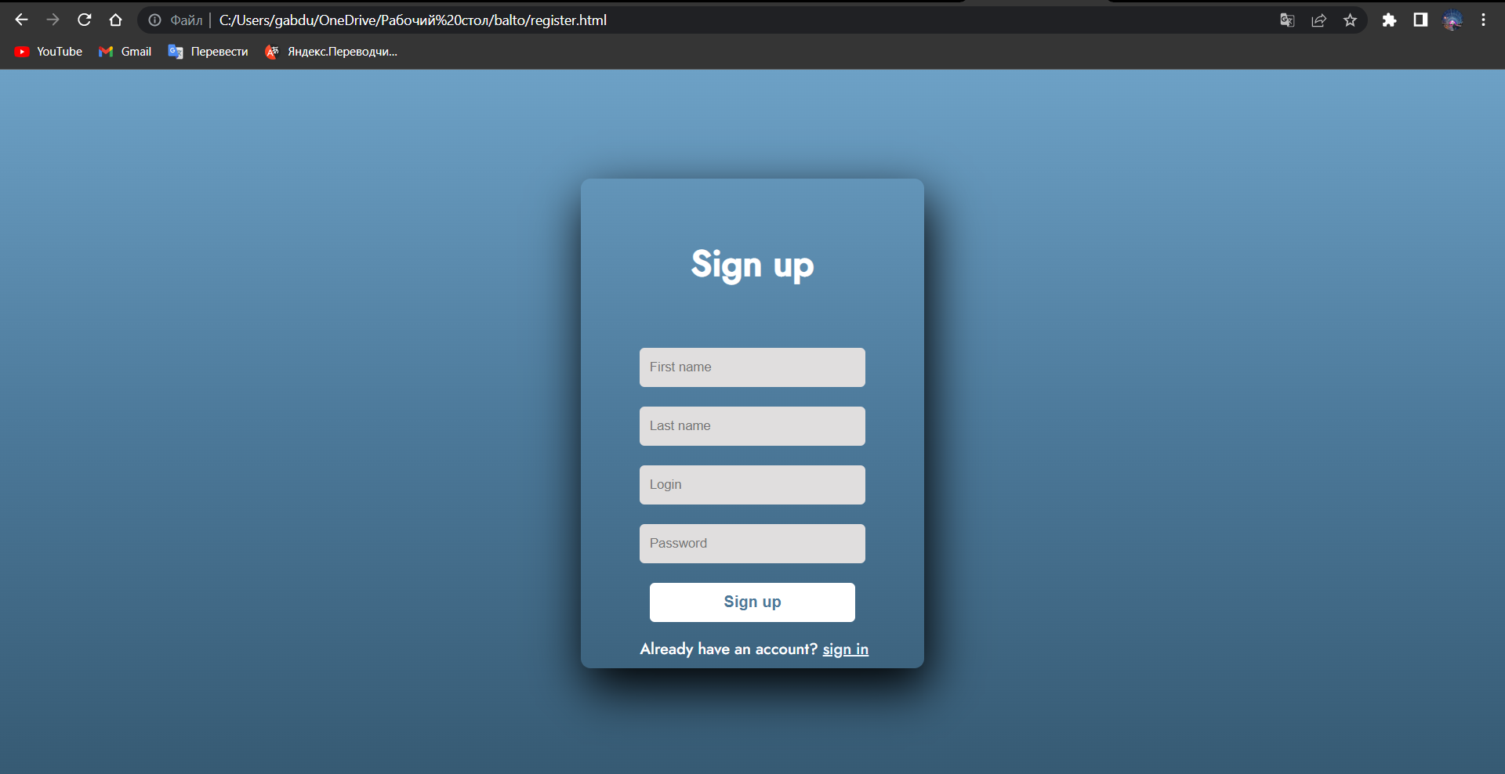

Picture 11. Login Page

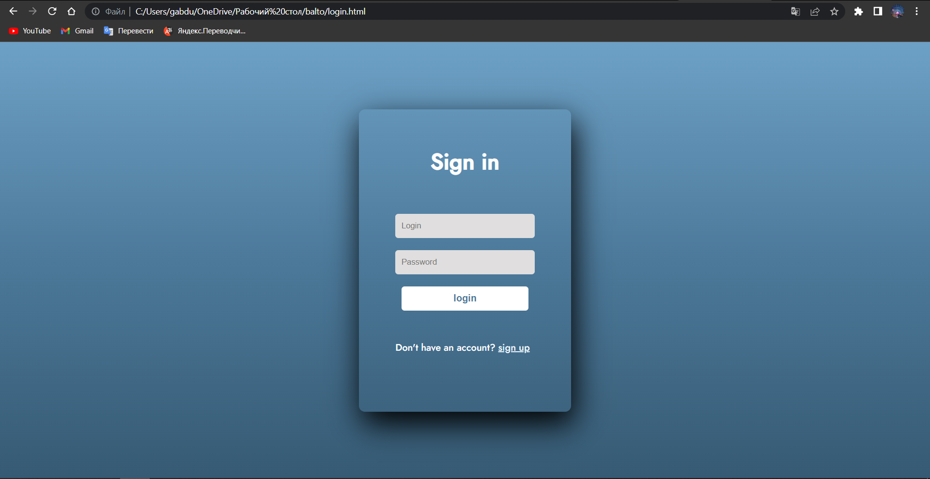

Picture 12. Sign Up page.

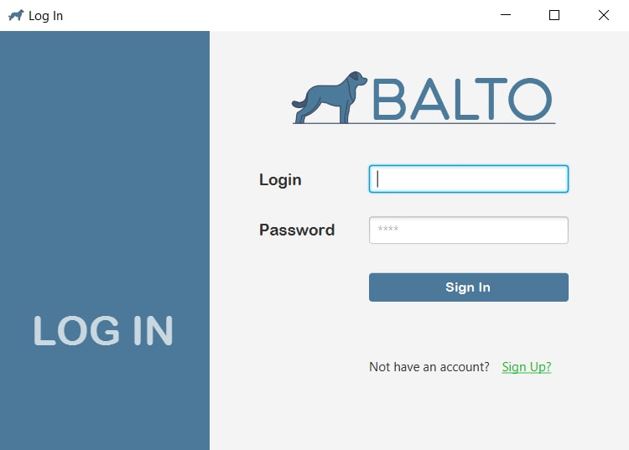

Picture 13. JavaFX Login page

Picture 14. JavaFX Messages

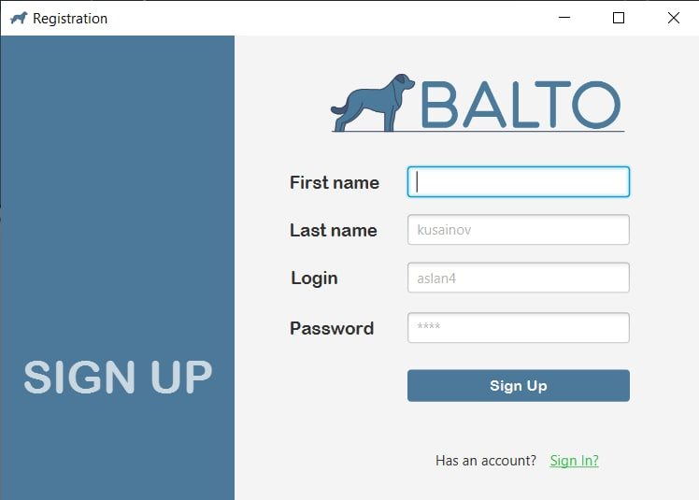

Picture 15. JavaFX Registration

Picture 16 All tables

Picture 17. Singleton pattern